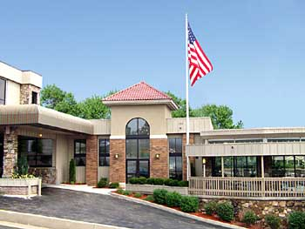
Best Western Plus Landing View Inn and Suites
403 West Main St Branson Mo, 65616
Phone # 1-417-334-6464 or toll free
1-800-828-0404.Please call us to make your reservations for the Prayer Mountain in the Ozarks
When you call to make your reservations please be sure to mention Billye Brim and the dates 8-2-13 through 8-7-13 to get the discounted group rate.

We have the standard rooms with 2 full size beds at the group rate of $93.00 plus tax a night.
We also have the standard king rooms at the group rate of $97.00 plus tax a night.
All rooms come with a nice hot breakfast, heated indoor 24 hour pool and an outdoor 24 hour hot tub.
All rooms do have a mini fridge, microwave, single cup coffee maker, d.v.d player.
And for your convenience we are staffed 24 hours.

